OO Programming Fundamentals

Practical Class 4 – Week 14th October 2013

- Create a new folder in your java folder on your G drive and call it practical04
- Save all the following exercises into the practical04 folder
- Ensure that you move to the correct folder when using the Command Prompt Window:
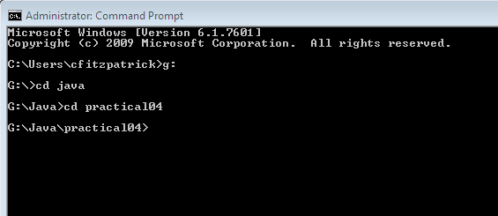
- You must run setpath from whichever folder it is stored in.

Exercise 1
Write a program which asks the user to enter 2 integer numbers. The program should give an output declaring which of the 2 numbers is larger or if they are equal.
Save as ex4a.java

Sample Output:

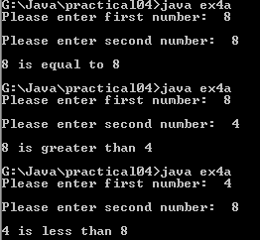

Exercise 2
Write a program which takes as input any three integer values, and determines which is the largest number.
Save as ex4b.java

Sample Output
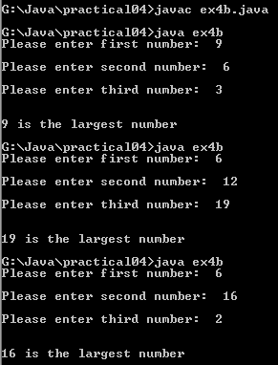

Exercise 3
Write a program to read a month number (i.e. 1 to 12) and print one of valid or not valid.
Save as ex4c.java
Sample Output:
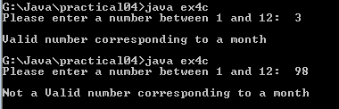

Exercise 4
A coach is organising a sporting event and wishes to separate competitors into three different categories according to age. The three categories are as follows:
- Under 14 Category A
- 14 but under 16 Category B
- 16 or over Category C
Write a program that requests a user to enter the age of a competitor and outputs the appropriate category.
Save as ex4d.java
Sample Output
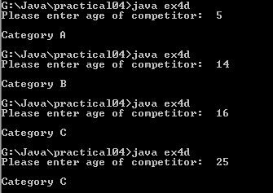

Exercise 5
A photo-copying centre charges 5 pence per copy for the first 100 copies and 3 pence per copy for each additional copy. Write a program that requests the total number of copies a user would like photocopied and then displays the total cost.
Save as ex4e.java

Sample Output:
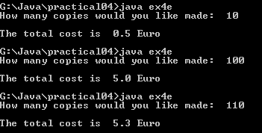

Exercise 6
Write a program to read a student’s percentage mark, check that it is valid and, if so, print one of distinction, merit, pass, or fail.
Note: A valid mark is one in the range 0 .. 100 and the grades are broken down as follows: 100 ≥ distinction ≥ 80, 79 ≥ merit ≥ 65, 64 ≥ pass ≥ 50, fail ≤ 49
Save as ex4f.java
Sample Output:
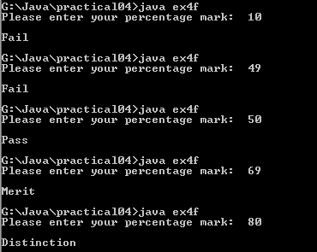

Exercise 7:
Write a program which asks the user to enter their gross wage. The first €80 is not subject to tax. The second €80 is taxable at 24% and the balance is taxable at 42%. The output should give the gross and net pay.
Save file as ex4g.java
Sample Output

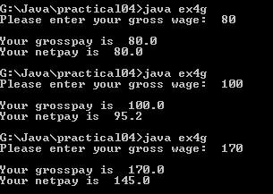

Completing this weeks’ Practical:
Zip Practical04 folder and upload the zipped file to Moodle.

